 | 
Data Flow Diagram
Date July 7, 2026
Team ID 12344
Project Name Opticrop
Maximum Marks | 2 Marks
Data Flow Diagram
Create a Data Flow Diagram (DFD) to show how data moves through your system - between external entities, processes, and data stores. Use the symbol legend below as a guide.
DFD Symbol Legend
Symbol | Name | Description
Oval / Rounded shape | External Entity | A person, organization, or system outside the project that sends or receives data (e.g.,  Customer, Payment Gateway).
Rectangle with  numbered header | Process | An activity that transforms incoming data into outgoing data (e.g., Validate Request, Process Order).
Rectangle (solid fill, no number) | Data Store | A place where data is held for later use (e.g., Customer Database, Inventory).
Labeled arrow | Data Flow | The movement of data between entities,  processes, and data stores, labeled with what data is being passed.
Example
The diagram below illustrates how the symbols above come together to form a complete data flow diagram.

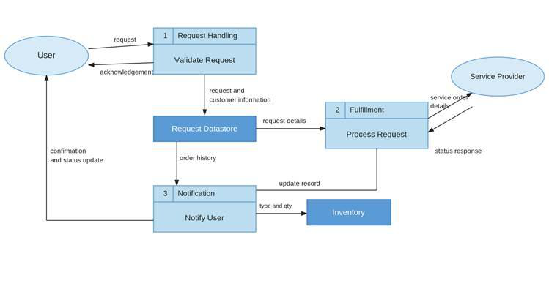
 | 
Opticrop - Level 0 & Level 1 Data Flow Diagram
[ Farmer / Researcher ]
| ^
(NPK & Climate inputs) (Crop & Yield results)
|
v
+---------------------------------------+
| 1.0 Input Validation & Bounds Check |
+---------------------------------------+
|
v
+---------------------------------------+
| 2.0 ML Inference (RF / KMeans .pkl) |
+---------------------------------------+
|
v
+---------------------------------------+
| 3.0 NPK Correction & Yield Estimate |
+---------------------------------------+
|
v
+---------------------------------------+
| 4.0 Flask Render / JSON Response |
+---------------------------------------+
|
v
[ User Browser ]
|
v
[ user_predictions.csv (CSV log) ]

